Transforming Transportation

# Opening Activity: What Needs to Change?

**What would need to change to make all cars and public transit electric?**

|  |
| --- |
|  |

# The Big Question

How can electric vehicles support our transition away from fossil fuels?

# My Climate Goals

When you complete this lesson, you’ll be able to:

1. Describe the benefits of electrifying transportation and explore solutions to some of the most significant barriers
2. Identify climate-critical professionals who work on electric vehicles and charging infrastructure
3. Discuss what communities need to electrify transportation fully.

**Notes:**

|  |
| --- |
|  |

# 

EV Charging Network Design

# Instructions

The City Planner has asked you to propose a new EV Charging Network for downtown in your small city. This network should be accessible and beneficial to residents and businesses and should help encourage the community to use more electric vehicles.

Below are the criteria and considerations for this proposal. On the following pages, you will find additional notes collected by the City Planner and a map of downtown.

**Budget**: $100,000

**Criteria for Ideal EV Charging Network**:

* **Accessibility**: Stations should be close to heavily trafficked locations, such as transit hubs, business districts, and residential neighborhoods.
* **Public Support**: Minimize disruption to community spaces, avoid excessive inconvenience to businesses, and consider anticipated public resistance.
* **Efficiency**: Place stations in areas with the most need or expected demand to maximize the budget’s impact.

|  |  |  |  |  |
| --- | --- | --- | --- | --- |
| Charger Type | Cost | Use | Space Required | Install Time |
| Small: 2 ports per station | $10,000 | Car only | 10’ x 20’ | 1 month |
| Medium: 4 ports per station | $25,000 | Cars, e-bikes | 20’ x 30’ | 2 months |
| Large: 6 ports per station | $45,000 | Cars, Bus | 30’ x 40’ | 3 months |

**Notes:**

|  |
| --- |
|  |

The City Planner has shared the following notes with you about possible public concerns related to EV charging stations downtown:

**Notes from the City Planner**:

**North Neighborhood Residents** have high incomes and support clean energy, but they are concerned about the convenience of using EVs without home charging stations.

**Downtown Business Owners** worry that charging stations will take up too much space and make parking tricky for customers. They may oppose large installations unless clear benefits to foot traffic or customer satisfaction are shown.

The **School and Park Area** sees high foot traffic, especially before and after school. Residents in the South Neighborhood and students’ families use the park frequently and would appreciate convenient charger access. Some residents are concerned about changes affecting green spaces.

**Commuters at Train Stations** rely on the train to travel to work and are interested in using EV charging facilities while they’re at work. However, any installation would need to be coordinated with transit authorities.

The **Bus Depot and Transit Center** are frequently used by transit vehicles, and drivers may need charging options for future electric buses. Some unused space exists, but placing chargers here may lead to construction delays and minor transit disruptions.

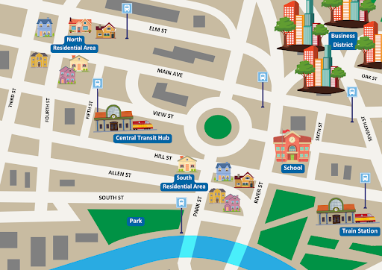

# Design Prompts

The City Planner has asked you to propose a new EV Charging Network for downtown in your small city. This network should be accessible and beneficial to residents and businesses and should help transition the community to use more electric vehicles. Prepare your plan using the prompts below.

**How many of each type of charging station will you build?**

|  |
| --- |
|  |

**What are the 1-2 most substantial benefits of this plan for the community?**

|  |
| --- |
|  |

**What concerns do you anticipate from community members and how will you address them?**

|  |
| --- |
|  |

**What factors were most important when designing your EV charging network? Why?**

|  |
| --- |
|  |

# Lesson Key Points

* Electric transportation helps reduce emissions, improve air quality, and support grid resilience.
* Barriers include cost, infrastructure limitations, and public resistance to change.
* Careers in EV technology are critical to achieving sustainable transportation.

**Additional key points:**

|  |
| --- |
|  |

# Closing Activity

**If you could add one feature to EVs to speed up public transition, what would it be and why?**

|  |
| --- |
|  |

**What do you think is the greatest challenge to transit-oriented development?**

**How might this challenge be addressed?**

|  |
| --- |
|  |

**Careers of interest you heard about in this lesson:**

|  |
| --- |
|  |